The Society for
Creative Anachronism

The Society for Creative Anachronism (SCA) is a not-for-profit educational organization dedicated to the study of the Middle Ages and the Renaissance. There are 50,000 participants worldwide who recreate many different aspects of these eras, including fighting, fencing, archery, and numerous arts and handcrafts.  Members learn about the eras they study through research and by wearing the clothing of the time and doing the activities practiced between 600 and 1600 A.D. .  The SCA is open to all. If you would like more information about the SCA and how you can become involved, please go to www.sca.org. Or contact your local group: [insert local kingdom/branch information]. | 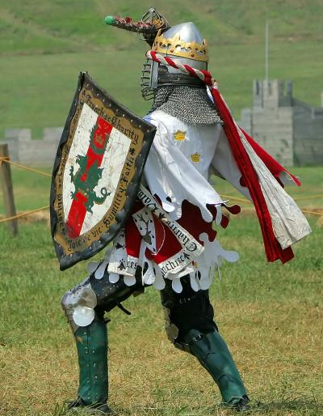

SCA Group Name  Contact name  phone/email | SCA Group Name  Contact name  phone/email | SCA Group Name  Contact name  phone/email | SCA Group Name  Contact name  phone/email | SCA Group Name  Contact name  phone/email | SCA Group Name  Contact name  phone/email | SCA Group Name  Contact name  phone/email | SCA Group Name  Contact name  phone/email | SCA Group Name  Contact name  phone/email

